{{DATE}}

**{{CLIENT_NAME}}**

**{{ADDRESS}}**

**ATTENTION: {{CONTACT_PERSON}}**

Dear Sir/Madam,  
  
We take special pleasure in submitting our firm quotation for the KYOCERA DIGITAL COPIER ECOSYS MA3500cifx as follows:

**FULL-COLOR MACHINE (BLACK AND COLORED PRINT/COPY/SCAN)**

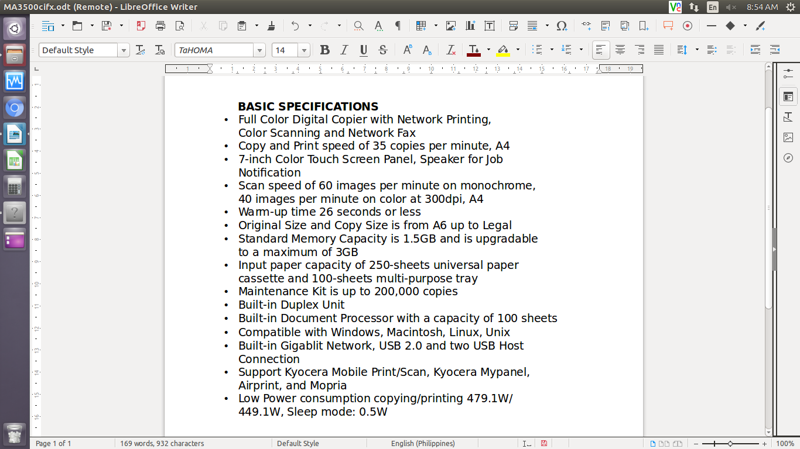

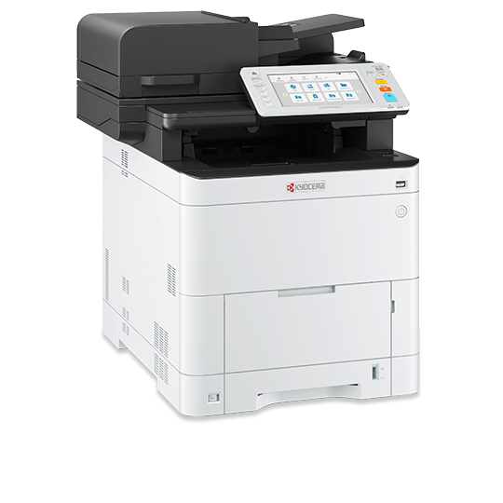

* **PRICE OF MACHINE AND ACCESSORIES**

|  |  |  |
| --- | --- | --- |
| 1 unit of KYOCERA DIGITAL COPIER ECOSYS MA3500CIFX | Php | 120,000.00 |

**PROMO PRICE**

MACHINE ORIGINAL PRICE Php 120,000.00

LESS PROMO DISCOUNT Php 33,000.00

,==========================================================================

TOTAL DISCOUNTED AMOUNT Php 87,000.00 (Less 10% in COD = Php 78,300.00)

**==========================================================================**

Php 7,250.00/MO FOR 12MOS. (CREDIT CARD)

**OPTIONAL/ACCESSORIES (NOT INCLUDED IN THE MACHINE PRICE)**

WIFI DIRECT/ WIRELESS LAN Php 8,000.00

PAPER CASSETTE/FEEDER Php 21,300.00

ADD’L 3 YEARS SERVICE WARRANTY EXT Php 8,400.00 (TOTAL 5 YEARS)

STEEL TABLE/CABINET Php 6,700.00

* **PRICE OF CONSUMABLE (PLUS 12% VAT)**

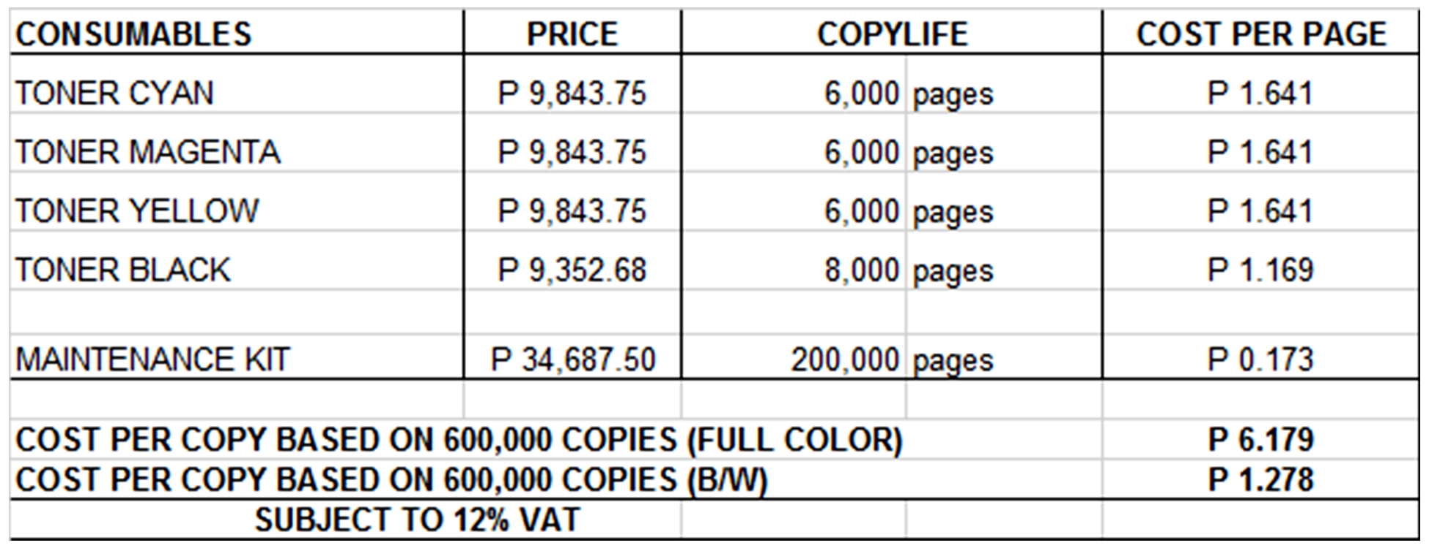

**Terms of Payment:** COD CASH/ BANK TRANSFER / CREDIT CARD ONLINE  
  
**VALIDITY:** Prices are subject to change without prior notice, please confirm with us before finalization of the order.  
  
**WARRANTY:**  
KYOCERA DIGITAL COPIER ECOSYS MA3500cifx is guaranteed spare parts replacement free of charge for ONE (1) YEAR or up to 200,000 copies/print/scan/fax, whichever comes first. Warranty for options and accessories is valid for ONE (1) YEAR from the delivery date.  
  
We also assure you of prompt service whenever you need assistance. Repair service is FREE for TWO (2) years. Should our machine require prolonged service, we shall install a backup unit for your convenience.

Important Guidelines: To ensure that our MFP meets the high standards of our customer's quality expectations and functions according to its warranty life, please adhere to the guidelines below:

1. min. monthly output: 2,000 copies/max monthly output: 100,000 copies  
2. minimum color usage rate: 600 copies  
3. temperature:16 C to 27 C  
4. humidity: 36% -65%  
5. paper quality: thickness should be at least 80gsm, white, smooth, and dry  
6. paper quality: white, smooth & even surface, non-fibrous, least dusting, and non-moisture absorbent  
  
Special paper such as Transparency, adhesive-backed label paper, envelopes, colored paper, pre-printed paper, recycled paper, postcards, bond paper, and vellum can be used when it is under the correct specifications. For special papers not listed here, try testing them first with the MFP to ensure that the quality is satisfactory.  
  
Do not use the following paper type: coated or surface-treated paper, paper with plastic or carbon fibers, glossy paper, and perforated paper.

Moreover, the amount quoted above excludes the cost of any required tests or medical certifications such as, but not limited to Rapid tests, Antigen tests, and RT-PCR tests. The actual cost will be billed separately

We are looking forward to hearing from you soon. For any questions or concerns, please feel free to call us at 7618-0274/09176240820.

Very truly yours, Conforme:

**JAYPEE V. SONIEL __________________________________**  
SENIOR ACCOUNT EXECUTIVE II

09176240820 (Viber Ready)